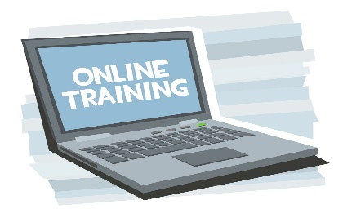 PA Training
This Photo by Unknown Author is licensed under CC BY-SA
The Direct Payments team can arrange online training for your PA’s.
This is accessed via the NHS training website called e-LfH.
There has been a core set of 7 training modules identified to support your PA’s to carry out their role effectively in line with current NHS guidance and standards.
- Equality and Diversity and Human Rights – Level 1
- Moving and Handling – Level 1
- Preventing Radicalisation – basic prevent awareness
- Resuscitation - level 1
- Safeguarding adults - level 1
- Safeguarding children – level 1
- Infection prevention and control – level 1

Your PA’s will be able to save and print off certificates as evidence of their continued personal development.

It will take approximately 4 hours to complete the modules. When your PA has completed and passed all 7 modules payroll can be informed to include an additional 4 hours @ £10.42 per hour (minimum wage) on their wage slip.
They can then, if they choose to do so, complete any of the other training modules that are available however this will be without payment for time taken.
To arrange training for your PA’s please contact your Direct Payments Advisor directly or email direct.payments@sefton.gov.uk

